Characteristics of Humans

**What makes a human?**

* Habitual obligate bipedal locomotion
  + Began to appear 7-6 MYA
  + **Australopithecines** show these traits (4 to 2 MYA)
  + ? Molecular clock evidence of Chimpanzees (close related relative)
    - Chimps are knuckle walking
* Derived dentition and jaw musculature
* Larger brains in relation to our body size
  + Neanderthals had larger brains than humans do but did not mean more intelligence
  + Began to appear in the genus **Homo** around 2 MYA
* Slower development
  + Sexual maturation, end of mating career
* Language and culture
  + Symbolism
  + Grammatical structure
  + Speech; making unique sounds
  + Around 200,000 years ago

# Challenge for Bipedalism: Balance

* Solutions involve structural changes
* Skull
  + Foramen magnum position

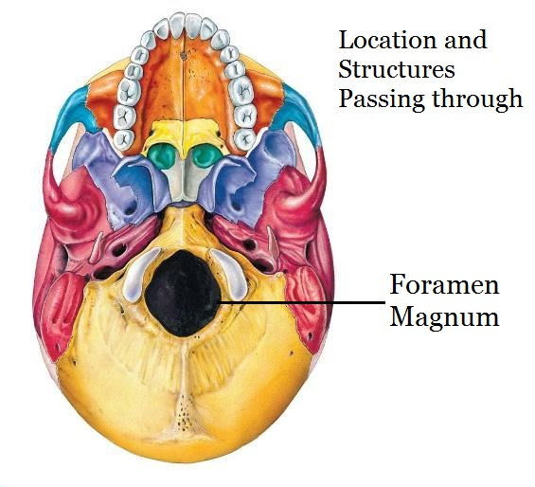

* + Hole at the base of the skull where the spinal cord and brain meet
  + Positioning of the foramen magnum is important for weight distribution
    - Moving the foramen magnum to the center of the skull means better center of gravity for walking hominins.
  + Humans have a nuchal plane that is parallel with the ground
  + **Nuchal plane**: giving attachment to the muscles of the back of the neck (red section)

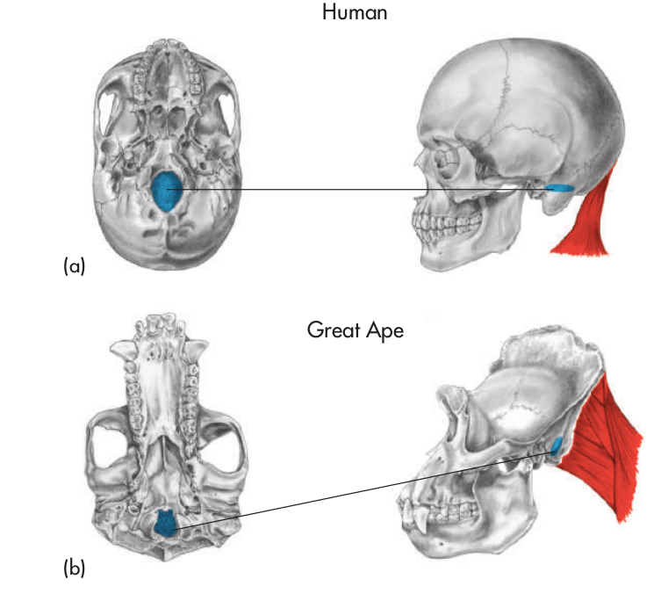

* A parallel nuchal plane allows hominins to look up as they walk, making it easier to for bipedality.
* Spine/vertebral column: new curvatures
* Bicuspid P_3
* Even though teeth are more delicate on humans than chimps, they have thicker enamel
  + Seems counter intuitive
  + 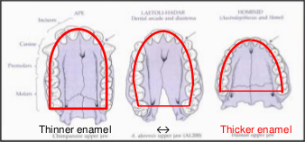
* Mouth of a chimp
* CP_3: sectorial canine/premolar honing complex, diastema
  + C: Canine
  + P_3: Premolar
  + Top canine is coming down and making abrasive friction much like a knife sharpener

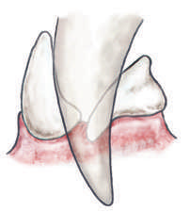

* Main difference between humans and chimps in terms of dentition
* **Sagittal Crest**: a bony ridge on the top of the skull to which the jaw muscles are attached.

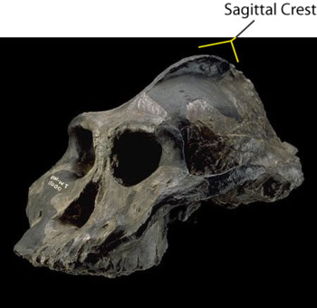

* Pelvis: shorter, broader to support weight alternating b/w legs

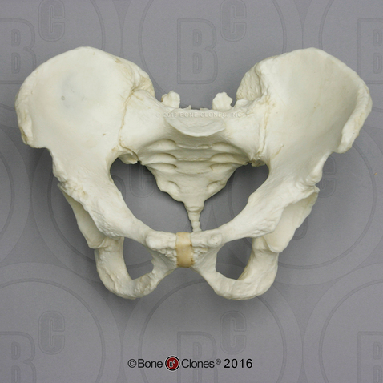 (Human Pelvis)

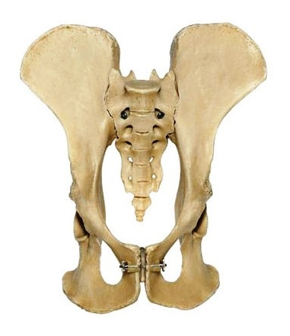(Chimp Pelvis)

* Torque produced by body weight
* Abductor muscles counteracts this torque created
* 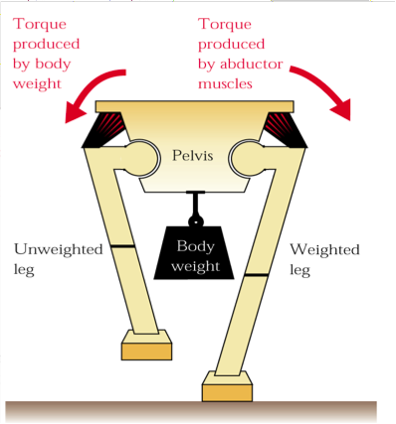
* Leg: angled femur, enlarged femur bottoms and tibia tops, longer legs and big gluteal muscles
* Foot: tarsals/heel, metatarsals

# Benefits of Bipedalism

* **Selection pressure:** role of changing environments
* Feeding posture for branches from ground
* Can carry more tools, resources
  + Paternal investment displayed by carrying provisions to base camp and intersex-selected for
  + Persistence hunting and efficient long distance travel (animal is injured, you chase after it until it is too tired and dies)
    - Gallop running has synchronized breathing and they cannot disconnect their breathing based on pace
    - Hands free for carrying
* Face-to-face sex and signaling sex, dominance displays for intrasex competition
* Fighting, punching
  + Intrasex selection, war
* Throwing: hunting and fighting
* Travel benefit on ground, seeing over grass for predator and resources
* Persistence hunting and efficient long distance travel
* Energy efficiency
  + Locomotion
  + Breathing, blood oxygen circulation
  + Cooling: upright posture, blood circulation, sweat

**Endocast:** the internal cast of a hollow object, often referring to the cranial vault in the study of brain development in humans and other organisms

* Shows longer childhood development
* What differs primates from other organisms

